Each week you are required to spend a total of 1 hour learning Spanish independently.

You will provide a brief report on your activity each week. This report will be submitted through Canvas. Your score will be recorded on a complete/incomplete basis and make up 10% of your overall grade for the course. Late forms may be accepted but will be subject to the -5% per day late work policy.
Choose from the following platforms to fulfill your 1 hour lab requirement each week. You may use a combination of these programs or use a single program for the duration of the lab.

DUOLINGO | QUIZLET | BK NELSON | SPINTX VIDEOS
 |  | 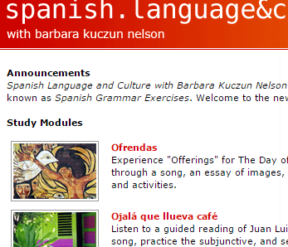 | 