SPA 101REV Nombre_________________
Homework Handout 5 Total _____/18.5

Before Reading/Antes de leer:

- Usando la estrategía de circunlocución, explica las siguientes palabras: (3 pts.)
  - Labrador _____________________________________________________________
________________________________________________________________________

  - Viejo ________________________________________________________________
________________________________________________________________________

  - Tener razón __________________________________________________________
________________________________________________________________________
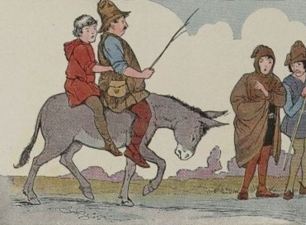
Read/Leer: Dos labradores con un burro (pp. 78-80)

After Reading/Después de leer:

1. En tus propias palabras, escribe un breve resumen de la lectura. (3 pts.)

______________________________________________________________________________
____________________________________________________________________________________________________________________________________________________________
______________________________________________________________________________
______________________________________________________________________________
______________________________________________________________________________
______________________________________________________________________________

Fonética (3.5 pts.)
The Spanish “r” is best described as the English sound produced by the two “ts” in the word “butter.” The double “r” is essentially that same sound but repeated. To produce the double “r” you’ll want to take a deep breath in and then pronounce the double “r” on your exhale as the sound requires a lot of air in the beginning until you get used to it’s articulation.

- There are several short tongue twisters on this website. Follow the link and click on 2 or 3 of the tongue twisters and practice the single and double “r” sounds in Spanish. (2 pts.)

- Write three words with the double “r” sound that you found on the website. (1.5 pts.)

  - ____________________ 2. ____________________ 3. ____________________

Gramática (9 pts.)

- Mira los siguientes videos en YouTube para repasar los conceptos de “gustar” y los demostrativos en español. (3 pts.)
  - Video de gustar
  - Video de los demostrativos

- Complete Part I of this online exercise to review the verb “gustar.”

- Complete this online exercise on the use of the demonstrative.

- I completed these tasks and they were awesome. (6 pts.)

I did not complete these tasks but I bet they were pretty awesome.

