SPA 101REV Nombre_________________
Homework Handout 7 Total _____/18

El principito: Capítulo 1

Before Reading/Antes de leer:

- Describe la imagen abajo. En tu opinión, ¿qué representa el dibujo? (En español) (2pts.)
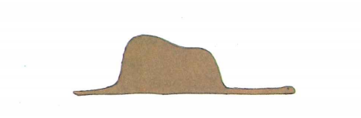
__________________________________________________________________________________________________________________________________________________________________________________________________________________________________________
Leer el capítulo 1 (pp. 5-9)

After Reading/Después de leer:

- Ahora describe la imagen arriba según lo que entiendes del primer capítulo. (en español) (1pt.)

____________________________________________________________________________________________________________________________________________________________

- Describe el narrador de la historia. Incluye todos los detalles que recuerdas del primer capítulo. (En español) (2pts.)

__________________________________________________________________________________________________________________________________________________________________________________________________________________________________________

Fonética
- The Spanish letter “c” produces to sounds. One is the sound found in the English word “cat,” and the other is the sound found in the English word “Ace.” Find out which contexts require one sound over the other, then complete the following questions based on what you find. Write “cat” if the “c” in the word is a hard “c” and “ace” if it’s a soft “c.” (5pts.)

Ejemplo: Conde cat

  - Consejero _________
  - Ocultaba _________
  - Gacela _________
  - Facilidad _________
  - Encontró _________

Gramática

- Watch this video about NC-PIG and pronouns. You’ll probably need to pause the video at some parts to give yourself enough time to read through the explanations. (1pt)

I watched the video __________ I didn’t watch the video __________

- What does NC-PIG stand for? (5pts.)
  - N
  - C
  - P
  - I
  - G

- Pick two of the contexts from NC-PIG and write a sentence in Spanish for them. (2pts.)
Ejemplo: G (gerund) Estoy comiéndola.
  - _________________________________________________________________
  - _________________________________________________________________

